**Handson 4**

CIE5141 Computer Vision in Construction

B07501113 林庭瑄

**1. Harris Corner Detection**

Step 2. Please paste the output images of I_x and I_y. (20%)

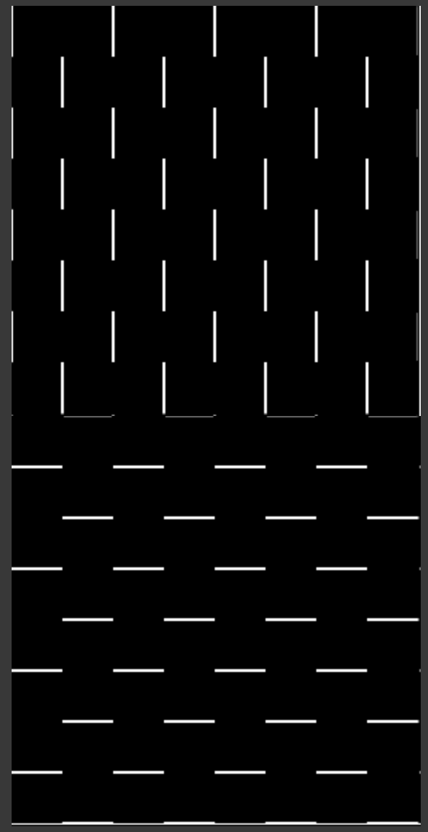

Step 3. Please paste the output images of I_x, I_y, and I_xy. (20%)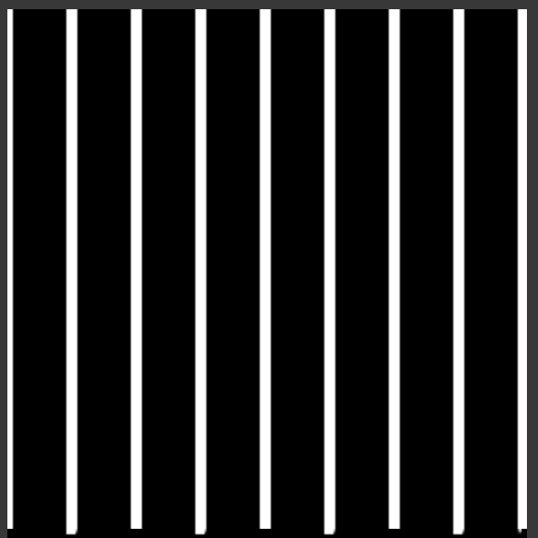

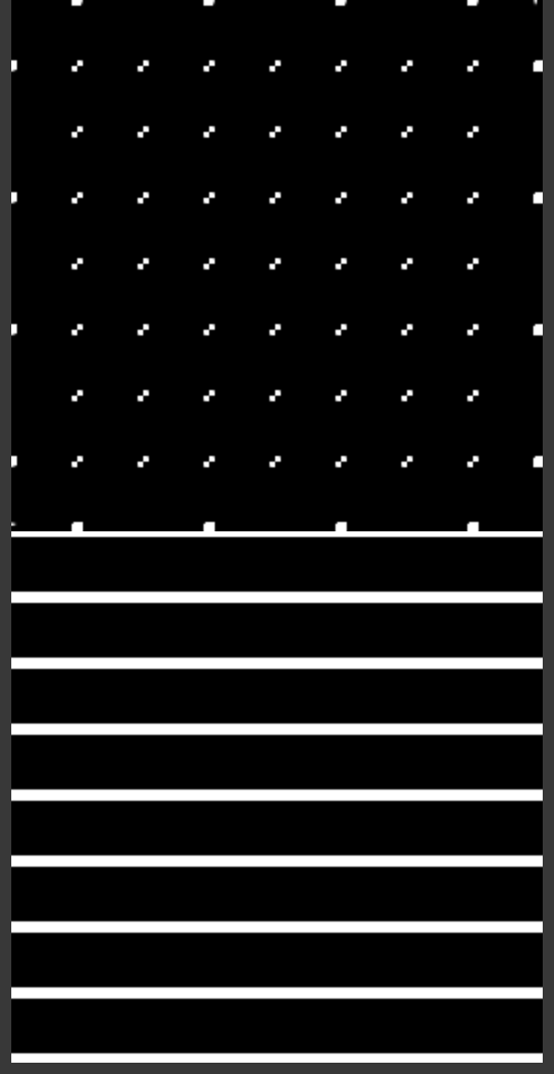

Step 4. Please paste the output image of harris corner detection. The threshold of the response should be 0.001 * R.max(). (20%)

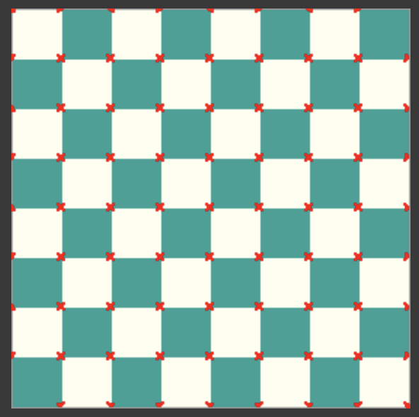

**2. Feature Space**

2-1. Please show the keypoints detected by ORB detector. (20%)

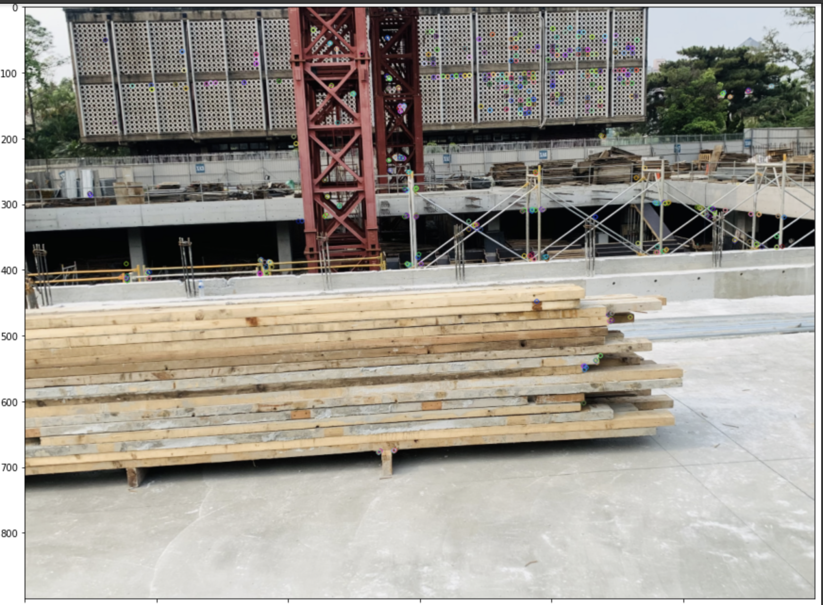

2-2. Please show the keypoints detected by SIFT detector. (20%)

